The objectives of PR in data breaches
The primary goal of PR services in a data breach is to mitigate reputational damage, reassure stakeholders, and ensure transparency while complying with legal obligations. An effective PR strategy can:

Objective | Benefit
Minimise customer churn | Retain trust and prevent loss of business
Mitigate financial risks | Reduce exposure to fines, legal costs, and revenue losses
Address public concerns | Provide clarity, empathy, and actionable solutions
Rebuild trust | Demonstrate accountability and long-term commitment to stakeholders

Key steps
- Crisis communication planning: Develop a detailed playbook that defines roles, messaging protocols, and communication channels.
- Stakeholder mapping: Identify and prioritise key audiences, from customers and employees to regulators and investors.
- Tabletop exercises: Simulate breach scenarios to test and refine communication strategies.
- Media training: Equip executives with the skills to handle media inquiries confidently.

Example playbook contents
- Contact details of the crisis team (internal and external).
- Protocols for media engagement.
- Draft templates for initial communication.
- Guidelines for updating stakeholders regularly.

Immediate response during a breach
When a breach occurs, time is of the essence. PR teams play a critical role in managing the crisis by:
- Assessing the situation: Understanding the scope and media landscape of the breach.
- Crafting key messages: Communicating what happened, the impact, and immediate steps being taken.
- Stakeholder outreach: Tailoring messages for affected parties, including customers, partners, and regulators.
- Leveraging communication channels: Using social media, press releases, emails, and dedicated web pages to inform and reassure.

“PR for Data Breach Management.” ITLawCo, 21 Jan. 2025, https://itlawco.com/pr-for-data-breach-management/


Examples of past data breaches, PR statements/efforts, and response

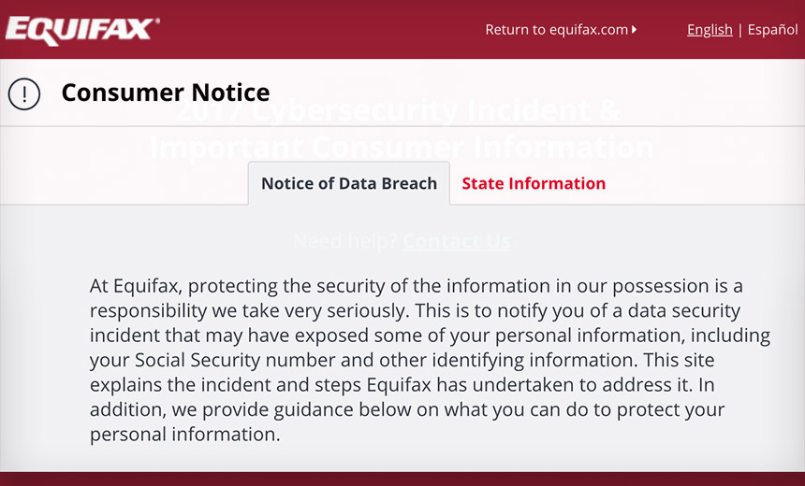
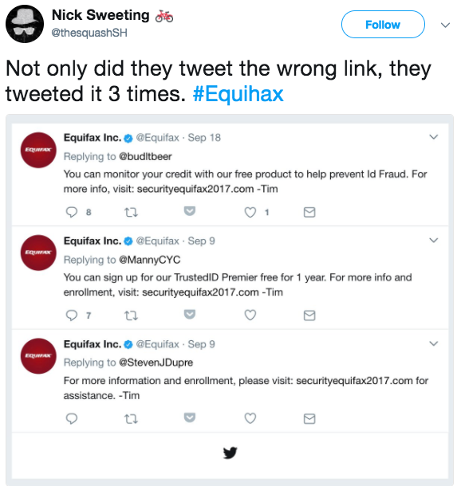
2017 Equifax Breach
In 2017, credit reporting agency Equifax suffered a massive data breach, exposing the sensitive personal information of approximately 147 million consumers, including Social Security numbers, birth dates, and addresses. Hackers exploited a known security vulnerability in the company's website that went unpatched, leading to one of the largest data thefts in history and resulting in over $575 million in settlements.

After the announcement, the initial reaction was one of outrage.
News segments were overwhelmingly critical of Equifax, and social media users were dismayed by the one-way nature of Equifax’s messages (Novak, 2019). While Equifax addressed concerns on social media, people were frustrated by responses that simply
redirected them to the crisis website. The website, however, also received widespread criticism. The online form prompted users to input their last name and six digits of their social security numbers to find out whether they were affected by the data breach.

Electronic Privacy Information Center (EPIC). “Equifax Data Breach.” EPIC, archive.epic.org/privacy/data-breach/equifax/.



2013 Target breach
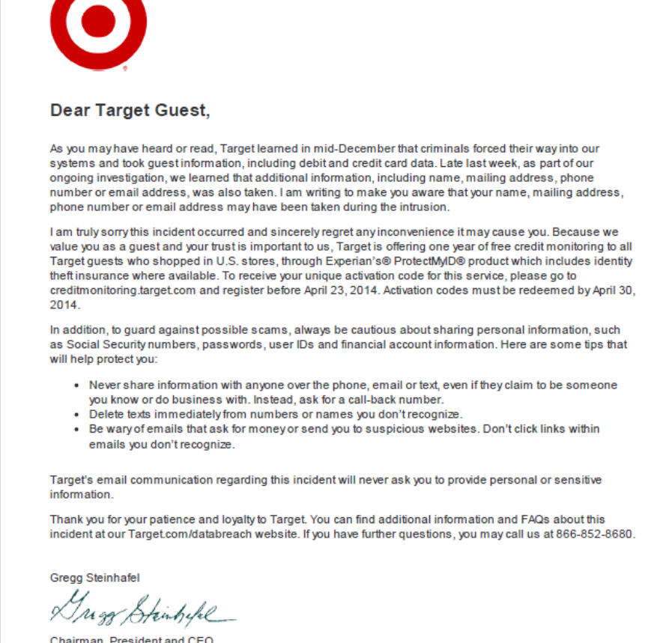
The breach unfolded during the 2013 holiday shopping season. Attackers first compromised Fazio Mechanical Services, a small HVAC vendor with remote access to Target’s network. Using the vendor’s stolen credentials, they entered Target’s internal systems and moved laterally until they reached point‑of‑sale (POS) terminals. There, they deployed BlackPOS RAM‑scraping malware, which captured payment card data from in‑store transactions.

When Target suffered its major 2013 data breach, the company demonstrated several strong incident‑response practices that organizations can learn from. They communicated openly once the breach was confirmed, offered free credit‑monitoring services, and launched a broad internal investigation to show accountability and support for affected customers. Target also committed to long‑term security improvements, investing heavily in better monitoring, vendor‑risk controls, and overall cybersecurity. However, the company was criticized for not acting sooner on early security alerts and for initially responding more slowly than customers expected, which contributed to frustration and loss of trust. Together, these strengths and shortcomings illustrate how transparency, customer support, and timely action are essential for rebuilding confidence after a security incident.

Steinberg, Sean, Adam Stepan, and Kyle Neary. Target Cyber Attack: A Columbia University Case Study. Columbia University School of International and Public Affairs, 2021.
www.sipa.columbia.edu/sites/default/files/2022-11/Target%20Final.pdf

Other examples of company responses

Context.ai
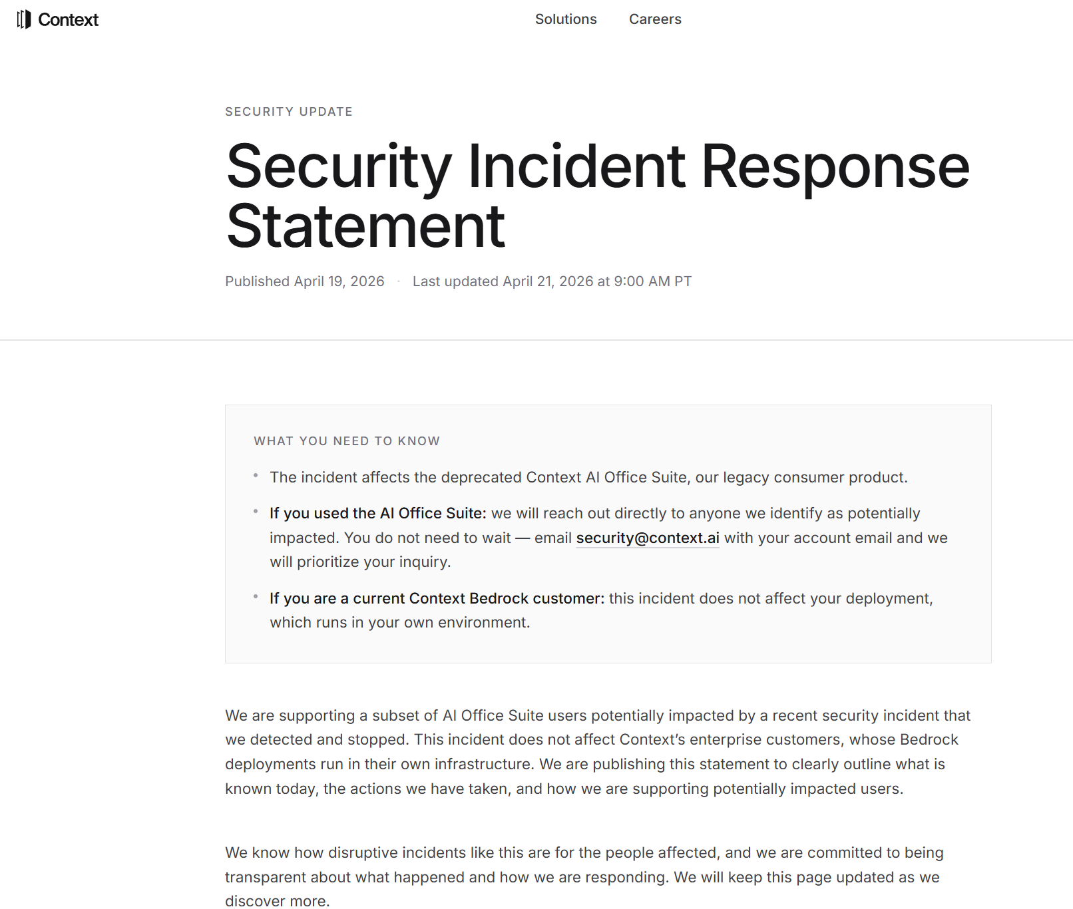

Full response here: https://context.ai/security-update

Vercel
Email sent to costumers

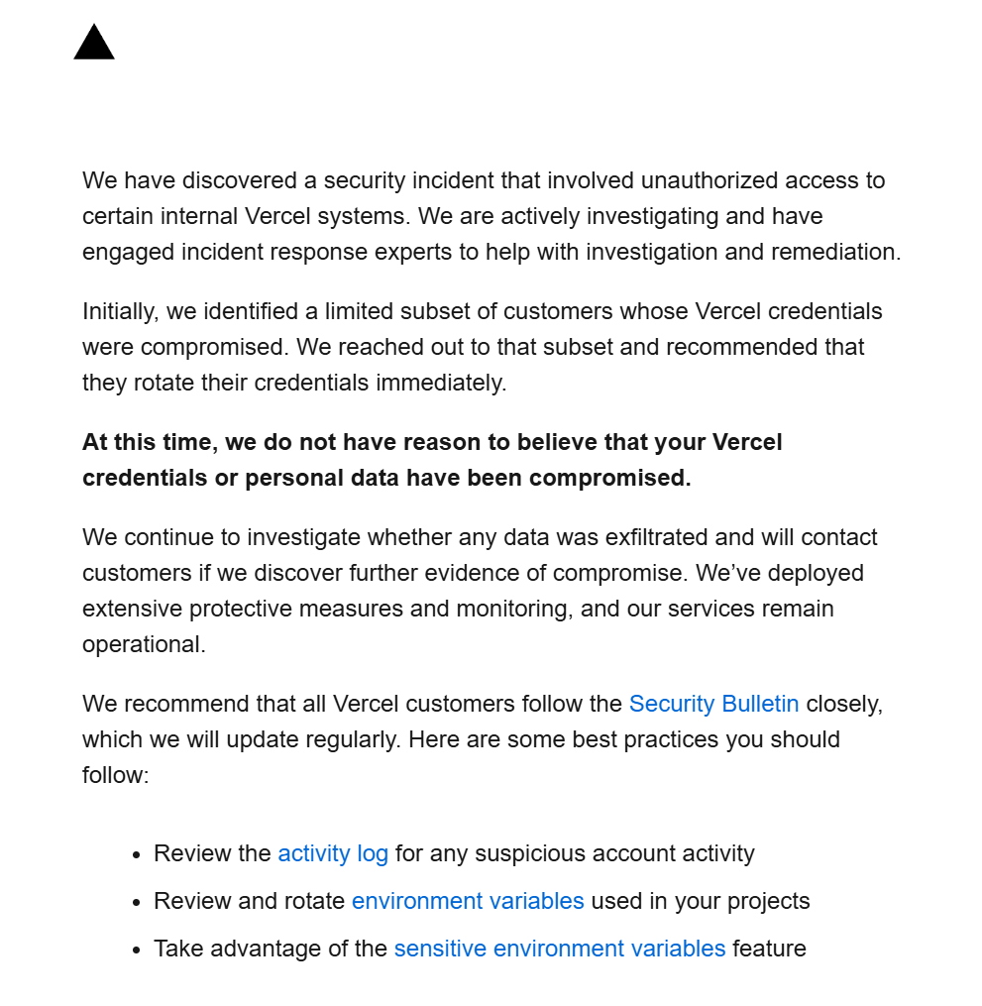

Full company response: https://vercel.com/kb/bulletin/vercel-april-2026-security-incident

